The Modelizer Phase 1

Defining the Shape

* **Researcher**
  + Agustin Salinas
* **Research Type**
  + Mid-Level: Literature Review (approx. 60 hours)
* **Research Premise**
  + This research investigates the energy and design implications of massing strategies in sustainable school architecture. Through comparative literature reviews and precedent analysis, it evaluates the tools and methods used by Lake|Flato and Overland for early design-stage sustainability modeling. By identifying proven massing modifications from CAE and COTE award-winning schools, this work will inform a design strategy for Kennedy Elementary that balances exterior modesty, energy performance, and site safety for outdoor learning.
* **Adventure Objectives**
  + Introduction of the Research and its alignment to Kennedy Elementary and other projects. Overall Goals of the work (250 Words). The why, covering Design Award submissions for AIA needed to have sustainable components of a project listed, as well as A4LE Design Submission.

This research, The Modelizer Phase 1: Defining the Shape, investigates massing strategies and early-stage energy modeling tools that inform sustainable design. Through a comparative literature review and precedent analysis, the study examines how design firms such integrate energy modeling into the conceptual and schematic design stages. Three modeling tools—Sefaira, Autodesk Forma, and Solemma Climate Studio—were evaluated for their usability, accuracy, and integration with existing design workflows. Sefaira and Climate Studio were found to be most effective for early and mid-stage energy and daylighting analysis, while Forma offered broader site-based assessments but lacked energy modeling capability.

The study further analyzed award-winning sustainable projects—Alice West Fleet Elementary School, John Lewis Elementary School, and Coliseum Place Affordable Family Housing, among others—to identify proven massing and orientation strategies that enhance building performance. Key findings highlight the value of east–west orientation, roof and façade optimization, and integrated photovoltaic systems in reducing energy use and improving daylight quality. The research also applied these strategies through iterative simulations for Kennedy Elementary School, using Sefaira-based analysis to refine daylight, and glare across seasons. Adjustments in shading, and glazing led to measurable reductions in heat gain and improved daylight distribution.

This foundational phase establishes a framework for applying validated sustainable strategies in ongoing and future projects within Pfluger Architects, supporting the firm’s mission of designing environmentally responsible and high-performing educational environments.

* Looking at Sustainable Wheelhouses of various firms. Comparing sustainability team structures and modeling tools and strategies used by Lake|Flato and Overland or others, identifying strengths and limitations of software and methods.
  + - Energy Modeling Tool A: Sefaira[1]
      * For this research, SketchUp with Sefaira extension were used.
      * Pros: Provides information that can assist projects in PD, SD, & DD stages. SketchUp extension is easy to use and does not require extensive information input. Sefaira Web app is more robust and provides more detailed information, and options can be created and compared. Evaluation tools include: Energy, Daylight, Envelope, and Photovoltaics.
      * Cons: SketchUp extension can fail when performing analysis and requires reboot, global parameters does not let customize wall construction separately, EUI analysis & results are very limited compared to Web app. Basic SketchUP skills required.
      * Image (web app):

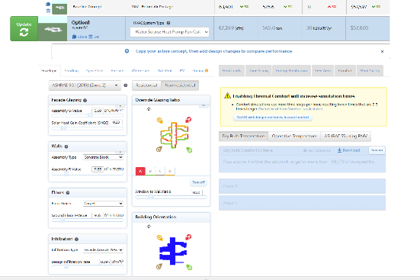

* + - * Pricing: $1,995 USD/Year/floating license seat
    - Energy Modeling Tool B: Autodesk Forma[2]
      * Forma is already part of Pfluger’s available softwares.
      * Pros: Offers a wide range of site design evaluation tools: daylight, wind, temperature, noise, solar energy, embodied carbon, and shadow study.
      * Cons: Does not offer energy modeling too.
      * Image

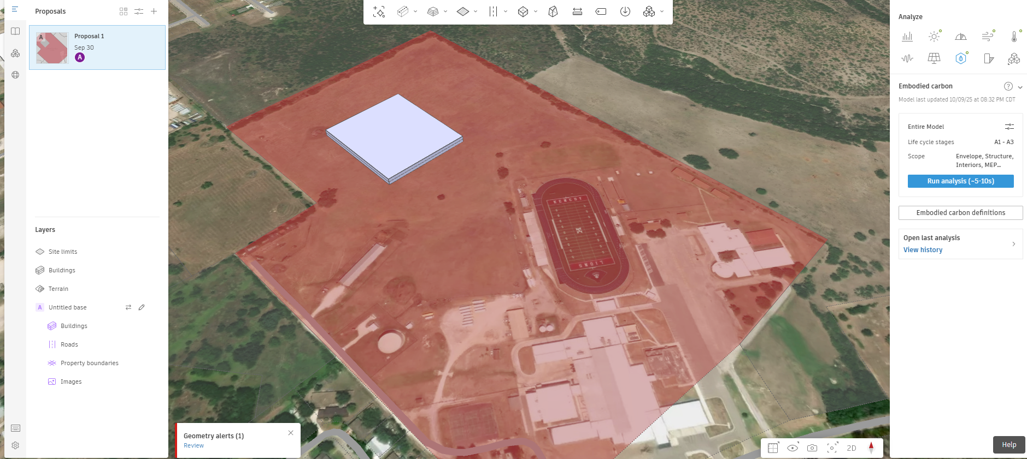

* + - * Pricing: $1,550 USD/Year/multi-user
    - Energy Modeling Tool C (Solemma Climate Studio)[3]
      * For this research, Rhino with Climate Studio extension were used.
      * Pros: This software can be used at DD, and CD stages for more detailed results compared to Sefaira. Evaluation tools include: Energy, Daylighting, Climate, Sun Path, Glare, Natural Ventilation, and Renewable Energy.
      * Cons: Requires intermediate Rhino skills.
      * Image

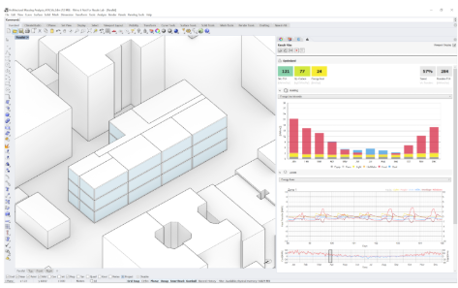

* + - * Pricing:
        + $2500 USD/year/floating license seat (for use by any employee from a single office)
        + $1250 USD/year/single user node-locked license
        + $200 USD/month/single user node-locked license
  + Analyze 2–3 CAE/COTE award-winning sustainable educational projects and 1 Pfluger project that demonstrate effective massing modifications for energy.
    - Project A[4][5]
      * Name: Alice West Fleet Elementary School
        + School District: Arlington Public Schools
        + Architect: VMDO Architects
        + Design Team:

General Contractor: Whiting-Turner Contracting Company

Engineer - MEP: CMTA

Engineer - Structural: Springpoint (formerly Fox & Associates)

Engineer - Civil: Bowman Consulting Group

Engineer - Landscape: Waterstreet Studio

Engineer - Traffic: Toole Design Group

Environmental Graphic Design / Wayfinding: Iconograph

Foodservice Design: EIS, Inc.

Parking: Rich & Associates

* + - * Location
        + Arlington, Virginia
      * Size
        + Total Site Area (gross sq. ft): 204,235 sq. ft.
        + Conditioned floor area: 111,634 sq. ft.
        + Stories: 6
      * Building Type (Main structural system, envelope, any novel materials)
        + Added insulation
        + Operable windows
        + Geothermal energy
      * Year Built
        + Project substantial completion date: 8/1/2022
      * Awards
        + AIA - COTE Top Ten, 2024
      * Sustainable Massing or Orientation Strategies
        + **Roof Plane and Shape Optimization**: Using roofs that don’t shade each other, concept design options were blocked and stacked with the sun, while keeping the principal parti axis east-west and minimizing the building footprint. The collection of the sun’s photons became a major driver of form.
        + **Massing Optimization**: The two “arms of the Y” each had less than ideal solar orientation. The arm aligned with the street used mass timber with deep overhangs to produce shade, while the other arm fine-tuned the angle and size of its apertures and used custom shading solutions.
        + **Vertical Plane Glazing Optimizat**ion: Each elevation was fine tuned to allow maximum daylight with minimal solar heat gain. Northwest facing classrooms “pushed out”, allowing floor-to-ceiling glass to face due north, while southeast facing classrooms did the opposite.
      * Images (in Egnyte folder)

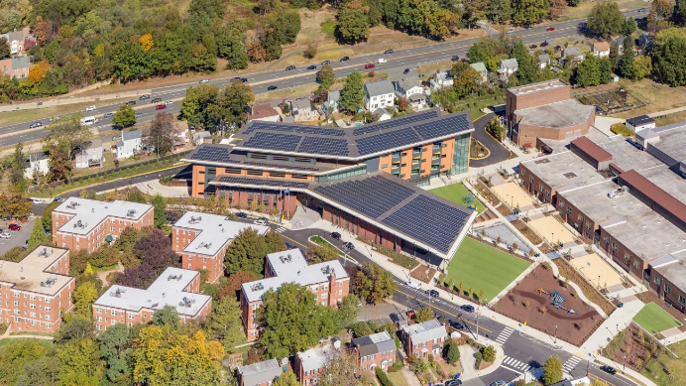

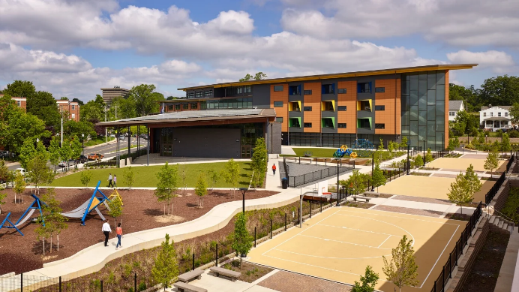

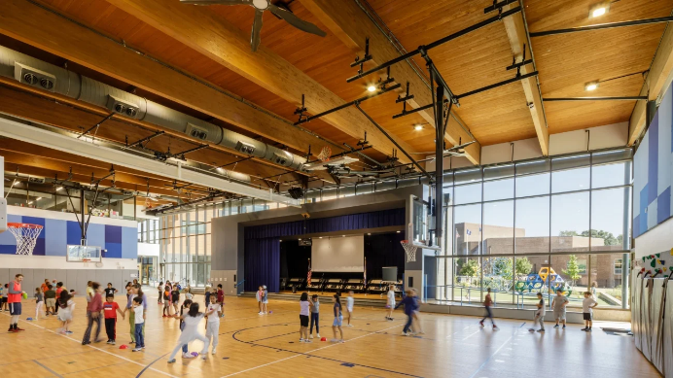

* + - Project B[6][7]
      * Name: John Lewis Elementary School
        + School District: District of Columbia
        + Architect: Perkins Eastman DC, Perkins Eastman Architects
        + Design Team:

Associate Architect - Interiors, FF&E: Perkins Eastman Architects

Builder and General Contractor: Gilbane Building Construction Company/Saxon Collaborative Construction Joint Venture

Consultant - Acoustics: Polysonics

Consultant - Food Service: Nyikos-Garcia Food Service Design Inc.

Consultant - Low Voltage: Innovative Systems Design & Training, Inc. dba Educational Systems Planning

Consultant - Sustainability: Perkins Eastman Architects

Consultant, Curriculum Integration: EcoRise

Engineer - Civil: Bowman Consulting

Engineer – ME: CMTA

Engineer - Energy Modeling: CMTA

Engineer – Plumbing and Fire Protection: Engenium Group

Engineer - Structural: Yun Associates

Landscape Architect: Natural Resources Design

* + - * Location
        + Washington, District of Columbia, United State
      * Size
        + Total Site Area (gross sq. ft): 162,948
        + Total Building Area (gross sq. ft): 88,588
        + Stories: 2
      * Building Type (Main structural system, envelope, any novel materials)
        + PV Panels on roof
        + Geothermal well field
      * Year Built
        + Project substantial completion date: 8/27/2021
      * Awards
        + AIA COTE Top Ten, 2025
        + 2023 American Architecture Award, The Chicago Athenaeum
        + 2023 Education-K-12 Winner: Planet Positive Awards, Metropolis magazine
      * Sustainable Massing or Orientation Strategies
        + **Massing Optimization:** Project team flipped the design previously done during the feasibility study and rotated it 90 degrees so that the building is oriented along an east-west axis. This decision alone resulted in a 9% reduction in energy consumption.
      * Images (in Egnyte folder)

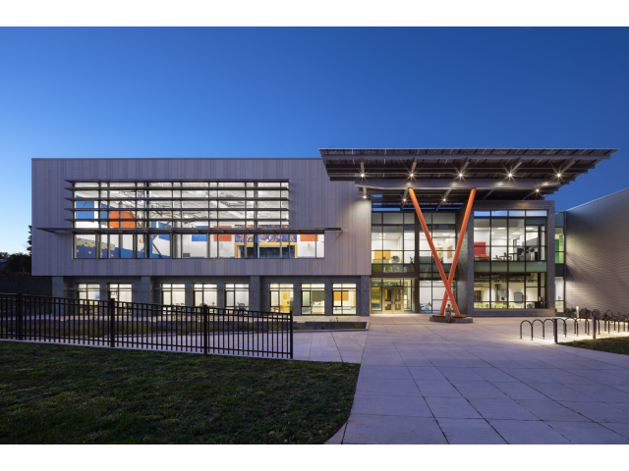

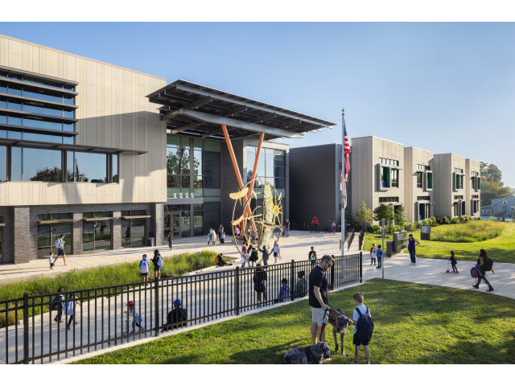

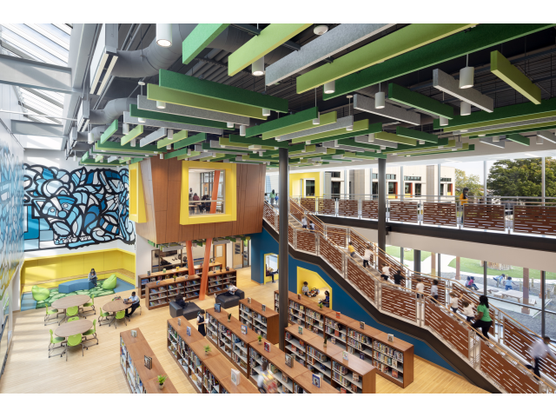

* + - Project C (Pfluger Project)[8]
      * Ask Frances
  + Summarize data on at least three CAE/COTE award-winning sustainable documented massing changes and their measured impacts, focusing on projects **outside of the Educational Sector**.
    - Massing Strategy Coliseum Place Affordable Family Housing [9],[10]
      * The design combines simple massing and solar orientation response as the basis for ambitious energy-consumption-reduction goals.
        + Simple Massing
        + Protective Solar Screen along south façade
        + PV Canopy

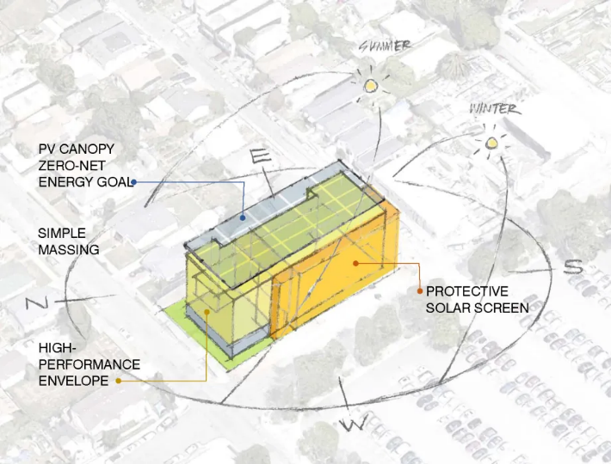

* + - * Project information
        + Name: Coliseum Place Affordable Family Housing
        + Location: Oakland, California
        + Total Site Area (gross sq. ft): 20,290
        + Total Building Area (gross sq. ft): 71,512
        + Building Type: IIIA, IA
        + Sector: Residential - Multi-Family, 5 or more units, Residential - Mid-Rise/HIgh-Rise
        + Project Substantial Completion Date: 12/8/2021
        + Estimated Occupancy: 59 apartment units
      * Building Performance Metrics (EUI, Embodied Carbon)
        + Measured EUI: 15 kbtu/sf-yr
      * Cost metrics (Energy reduction, Artificial Lighting Consumption Reduction, water reuse/reduction)
        + 98 kW PV array offsetting 100% of common loads
        + Decentralized water heating system
      * Material Consideration & Metrics (Envelope & interior Material Diversion/ Reduction/ Re-use, etc)
        + 81% construction waste diversion
      * MEP Consideration & Metrics (Required Specialty Systems, specialty consultants)
        + The design uses a decentralized hot water system with residential

heat pump water heaters to remove one of the biggest inefficiencies of

multifamily buildings.

* + - * Structural Considerations & Metrics (Slab/foundation, stick vs Core&Shell etc)
        + N/A
      * Any surveys or post occupancy information (psychological responses)
        + N/A
    - Massing Strategy: John W. Olver Transit Center [11],[12]
      * The design strategy utilized energy modeling, including sunpath diagrams to develop the building form. The second story cantilevers over the waiting area, providing shade and reducing summer solar heat gains.
        + 7,300 SF photovoltaic array
        + 22 geothermal wells
        + On-site wood-pellet boiler

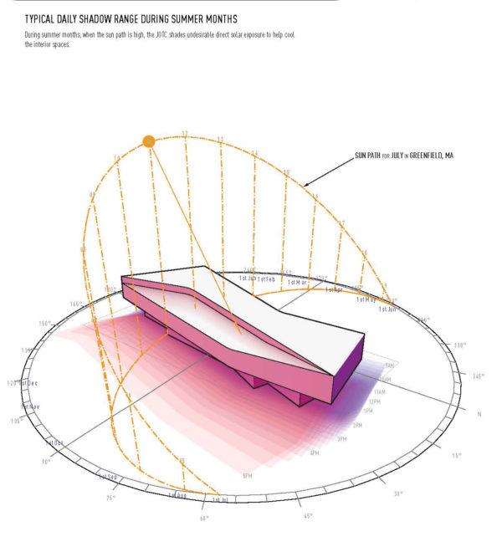 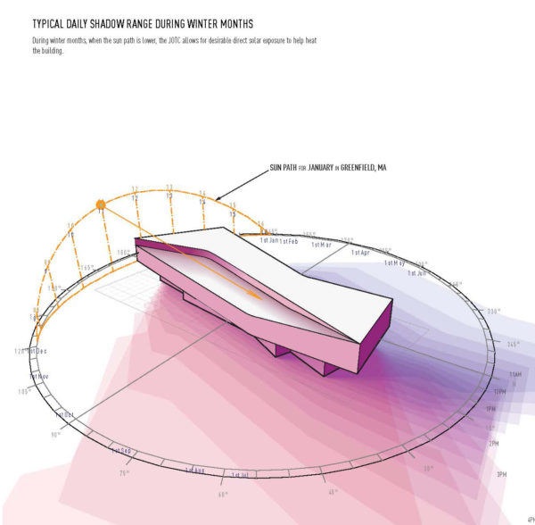

* + - * Project information
        + Name: John W. Olver Transit Center
        + Location: Greenfield, Massachusetts
        + Total Site Area (gross sq. ft): 81,400
        + Total Building Area (gross sq. ft): 24,000
        + Building Type: Unknown
        + Sector: Civic/Cultural
        + Project Substantial Completion Date: 2014
        + Estimated Occupancy: 3,750
      * Building Performance Metrics (EUI, Embodied Carbon)
        + Measured EUI: 21.3 kBtu/sf/yr.
      * Cost metrics (Energy reduction, Artificial Lighting Consumption Reduction, water reuse/reduction)
        + 98 kW photovoltaic array
        + 100% of total energy is derived from renewable sources
        + There is a 95.5% reduction (inclusive of renewables) in operational carbon from benchmark, measured.
        + Water use intensity (gal/sf/year)

Benchmark: 20.9

Predicted: 4.3

Measured: 3.1

* + - * + Reduction in potable water use (from benchmark)

Predicted: 79.5%

Measured: 85%

* + - * + Total annual water demand met using potable sources

Predicted: 100%

Measured: 100%

* + - * + 100% of stormwater is managed on-site.
      * Material Consideration & Metrics (Envelope & interior Material Diversion/ Reduction/ Re-use, etc)
        + The materials for the exterior—brick, copper and locally sourced stone
        + 100% of the installed wood is FSC certified
      * MEP Consideration & Metrics (Required Specialty Systems, specialty consultants)
        + The design uses a decentralized hot water system with residential

heat pump water heaters to remove one of the biggest inefficiencies of

multifamily buildings.

* + - * Structural Considerations & Metrics (Slab/foundation, stick vs Core&Shell etc)
        + N/A
      * Any surveys or post occupancy information (psychological responses)
        + The post-occupancy report analyzed the following aspects of the project: overall building energy use, lighting energy use, PV generation, receptacle use, mechanical system use, air handling systems, water source heat pumps, office temperature and humidity, domestic hot water, and building management systems. The building was performing well but energy consumption was slightly higher than projected. The analysis led to a second round of commissioning, which improved the efficiency of the building.  Some meters were inaccurate and were replaced. Some lighting controls were incompatible with some fixtures and were replaced. Building operations staff were given additional training in monitoring the systems.

Post-occupancy evaluation score: 100

Transparency score: 100

Commissioning score: 80

Feedback score: 100

* + - Massing Strategy Westwood Hills Nature Centerm[13],[14]
      * The envelope, orientation, and shading were optimized for efficiency to take advantage of existing site resources—sun and wind—and maximize use of passive heating, cooling, and daylighting.
        + Photovoltaic array
        + Geothermal well field

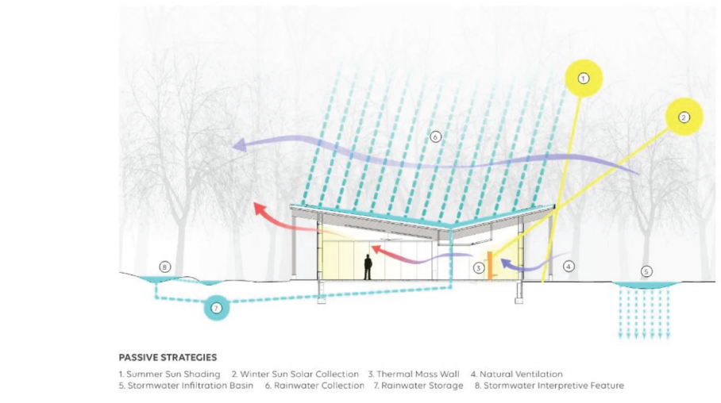

* + - * Project information
        + Name: Project highlights: Westwood Hills Nature Center
        + Location: St. Louis Park, Minnesota
        + Total Site Area (gross sq. ft): 167,088
        + Total Building Area (gross sq. ft): 13,565
        + Building Type: Unknown
        + Sector: Nature Center
        + Project Substantial Completion Date: 2020
        + Estimated Occupancy: 35,989
      * Building Performance Metrics (EUI, Embodied Carbon)
        + In its measured usage, including on-site renewables, the project achieve its 2030 Commitment reduction target (70% reduction by 2015, 80% reduction by 2020)
        + The project's total carbon (embodied + operational) over 10 years in kg CO2e is 198,789.9.
      * Cost metrics (Energy reduction, Artificial Lighting Consumption Reduction, water reuse/reduction)
        + 100% of total energy is derived from renewable sources
        + There is a 100% reduction (inclusive of renewables) in operational carbon from benchmark, measured.
        + Water use intensity (gal/sf/year)

Benchmark: 12.1

Predicted: 10

Measured: 10.2

* + - * + Reduction in potable water use (from benchmark)

Predicted: 17.5%

Measured: 15.8%

* + - * + Total annual water demand met using potable sources

Predicted: 100%

Measured: 100%

* + - * + 81.6% of stormwater is managed on-site.
      * Material Consideration & Metrics (Envelope & interior Material Diversion/ Reduction/ Re-use, etc)
        + Some of the installed wood is FSC certified
      * MEP Consideration & Metrics (Required Specialty Systems, specialty consultants)

The system setpoints were optimized to maximize efficiency, and energy loads were reduced using LED lighting and a geothermal well field to supplement the all-electric boilers as a heat source for the radiant floor. Use of WeatherShift to project future weather data, as well as historic data, in the energy model ensured future performance would meet the zero energy goal.

* + - * Structural Considerations & Metrics (Slab/foundation, stick vs Core&Shell etc)
        + N/A
      * Any surveys or post occupancy information (psychological responses)
        + A post-occupancy evaluation was conducted in November 2022, consisting of an online questionnaire and in-person focus group with employees, volunteers, and teachers. An in-person, 90-minute focus group was conducted with members of the nature center staff and included topics similar to those in the questionnaire. Findings were positive, including respondents' claim that the flexibility of the building spaces accommodates current and projected future needs.
        + The energy conservation of the building not only reduces resources needed to support building operation but also provides an educational opportunity for visitors. A curriculum was created about the building’s energy conservation.
        + Thermal imaging was used to identify air infiltration, leading to subsequent remedial work to repair holes in the air barrier at sprinkler pipe penetrations.

Post-occupancy evaluation score: 70

Transparency score: 80

Commissioning score: 40

Feedback score: 80

* + Using Energy modeling and daylight analysis to evaluate a base design, inform design revisions.
  + High-level DD interventions for Kennedy Elementary, focusing on reducing heat gain, glare, and improving seasonal daylighting and artificial lighting and spatial energy performance across the various spaces.
    - Seasonal Daylighting and Glare[15]
      * Intervention Strategy
      * Why Chosen, case study reference
    - Seasonal Heat Gain[16]
      * Intervention Strategy
      * Why Chosen, case study reference
    - South-facing collaboration spaces and classrooms[17]
      * Intervention Strategy
      * Why Chosen, case study reference
    - North-facing collaboration spaces and classrooms[18]
      * Intervention Strategy
      * Why Chosen, case study reference
    - Central library and common space[19]
      * Intervention Strategy
      * Why Chosen, case study reference

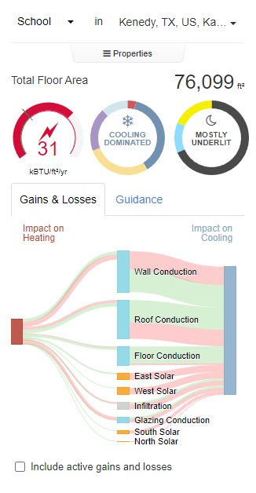

|  |  |  |  |
| --- | --- | --- | --- |
| **BASE MODEL** | | | |
|  | **9am** | **12pm** | **5pm** |
| **Spring** |  |  |  |
| **Summer** |  |  |  |
| **Fall** |  |  |  |
| **Winter** |  |  |  |



* + After a base simulation was preformed the results were handed off to the design team. Engaged in the iterative design process and the natural evolution of the school, modification were made to the plan area, shared and collab spaces.

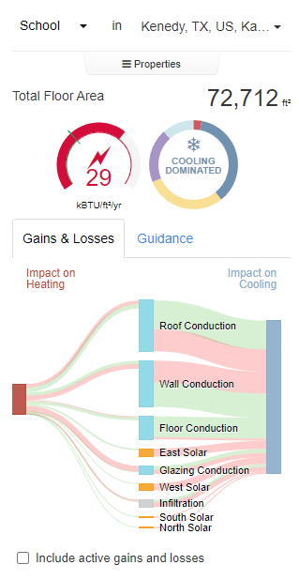

|  |  |  |  |
| --- | --- | --- | --- |
| **REVISED MODEL** | | | |
|  | **9am** | **12pm** | **5pm** |
| **Spring** |  |  |  |
| **Summer** |  |  |  |
| **Fall** |  |  |  |
| **Winter** |  |  |  |



* Brief expo about the comparison graph where the base revised model was evaluated, strategic alterations were made in the areas inline with the design parameters. Show compare graphic.

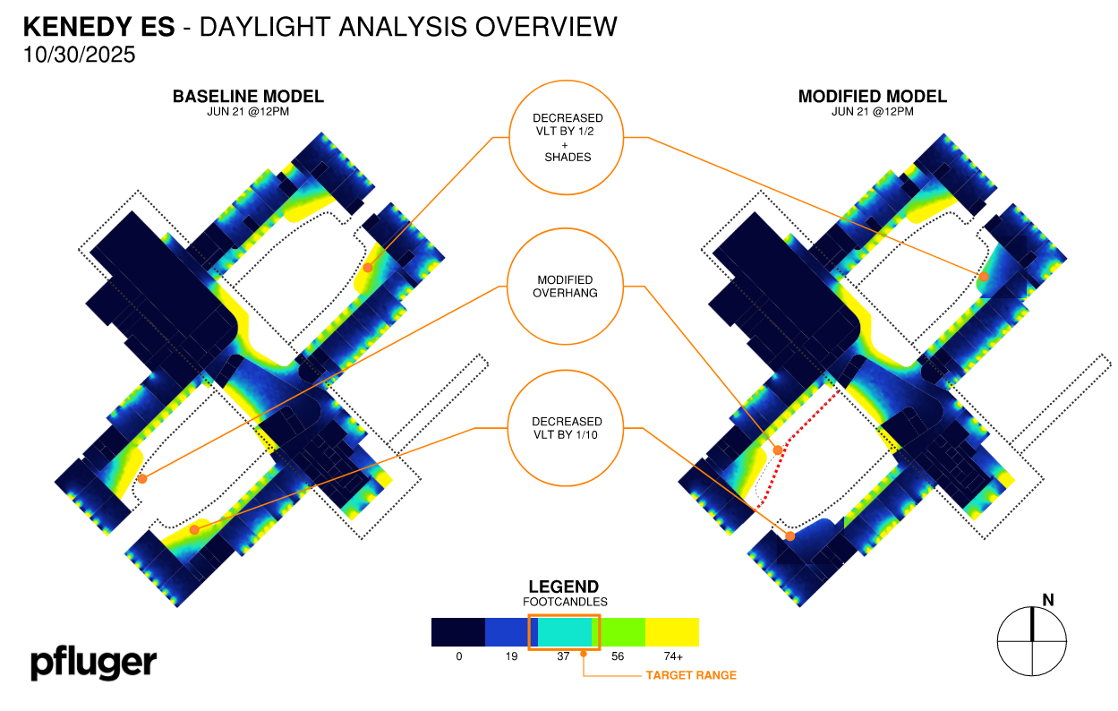

* Exhibit above shows the problematic areas in terms of glare and high footcandle readings of the current model (left side)
* Sefaira inputs were altered to provide design ideas to design team (right side)
  + - Seasonal Daylighting and Glare[20]
      * Simulation net (before vs after) Lux and EUI
    - Seasonal Heat Gain[21]
      * Simulation net (before vs after)
    - South-facing collaboration spaces and classrooms[22]
      * Simulation net (before vs after)
    - North-facing collaboration spaces and classrooms[23]
      * Simulation net (before vs after)
    - Central library and common space[24]
      * Simulation net (before vs after)
* Show final renderings
  + Conclusion of the Research and its alignment to Kennedy Elementary and other projects. Overall Goals of the work (250 Words)

The findings of The Modelizer Phase 1 demonstrate that thoughtful design—grounded in data-driven modeling and precedent analysis—has a significant impact on the sustainability performance of educational facilities. By synthesizing lessons from CAE and COTE award-winning projects, the study confirms that strategic orientation, and solar-responsive envelopes can lower energy consumption, mitigate glare, and enhance occupant comfort.

Applying these principles to Kennedy Elementary’s design process revealed key daylighting and glare challenges within the current building configuration. The design team will use these findings—supported by iterative simulation data—to refine shading strategies, window placement, and material selections to improve visual comfort, energy efficiency, and overall building performance.

This research not only aligns with Kennedy Elementary’s objectives but also establishes a transferable design methodology for future Pfluger projects such as Flour Bluff CET and Cornerstone. Moreover, the study provides a foundation for collaboration with academic and industry partners, such as UTSA and SunWest, to advance evidence-based design research and publication.

Ultimately, this work underscores the importance of integrating early-stage performance modeling into architectural practice—bridging qualitative design intent with quantitative environmental outcomes—to achieve buildings that are both contextually sensitive and energy efficient. The continuation of The Modelizer series will build on this phase to explore massing iteration testing, façade performance metrics, and cross-disciplinary collaboration for next-generation sustainable educational design.

* + Create a SharePoint page to share your research, and reference the Pfluger branding guidelines
* **Continuing research opportunity**
  + Apply research findings to develop and test 3–4 massing iterations for Flour Bluff CET, and or Cornerstone evaluating each for energy use, views, and façade metrics.
  + This work may feed into a higher education studio where students design the school alongside the research team, with client participation in critiques.
* **Resources & Partners**
  + UTSA (potential faculty collaborators)
  + Amanda with SunWest for publication
* **Identified future project alignment**
  + Cornerstone
  + Flour Bluff CET

1. https://sefaira.sketchup.com/page/projects
2. https://app.autodeskforma.com
3. https://www.solemma.com/climatestudio
4. https://www.aia.org/design-excellence/award-winners/alice-west-fleet-elementary-school
5. https://www.vmdo.com/alice-west-fleet-elementary-school.html
6. https://aia.secure-platform.com/a/gallery/rounds/723/details/59121
7. https://www.perkinseastman.com/projects/john-lewis-elementary-school/
8.
9. https://aia.secure-platform.com/a/gallery/rounds/723/details/61183
10. https://www.dbarchitect.com/projects/coliseum-place
11. https://www.aia.org/design-excellence/award-winners/john-w-olver-transit-center
12. https://www.charlesrosearchitects.com/projects/john-w-olver-transit-center/
13. https://www.aia.org/design-excellence/award-winners/westwood-hills-nature-center
14. https://hga.com/projects/westwood-hills-nature-center/
15.
16.
17.
18.
19.
20.
21.
22.
23.
24.